Student Name:………………………………………

SPECIALIST MATHEMATICS UNITS 3 & 4

TRIAL EXAMINATION 2

2024

Reading Time: 15 minutes
Writing time: 2 hours

Instructions to students
This exam consists of Section A and Section B.
Section A consists of 20 multiple-choice questions and should be answered on the answer sheet which can be found on page 26 of this exam.
Section B consists of 6 extended-answer questions.
Section A begins on page 2 of this exam and is worth 20 marks.
Section B begins on page 11 of this exam and is worth 60 marks.
There is a total of 80 marks available.
All questions in Section A and B should be answered.
In Section B, where more than one mark is allocated to a question, appropriate working must be shown.
An exact value is required to a question unless otherwise directed.
Unless otherwise stated, diagrams in this exam are not drawn to scale.
Students may bring one bound reference into the exam.
Students may bring into the exam one approved technology (calculator or software) and, if desired, one scientific calculator. Calculator memory does not need to be cleared. For approved computer-based CAS, full functionality may be used.
A formula sheet can be found at the end of this exam.

This paper has been prepared independently of the Victorian Curriculum and Assessment Authority to provide additional exam preparation for students. Although references have been reproduced with permission of the Victorian Curriculum and Assessment Authority, the publication is in no way connected with or endorsed by the Victorian Curriculum and Assessment Authority.

© THE HEFFERNAN GROUP 2024
This Trial Exam is licensed on a non transferable basis to the purchasing school. It may be copied by the school which has purchased it. This license does not permit distribution or copying of this Trial Exam by any other party.

SECTION A – Multiple-choice questions

Question 1

The negation of the statement ‘’ is

A.
B.
C.
D.

Question 2

The statement ‘For any , prove that if is even, then is even’ is most easily proved using

A. direct proof
B. contrapositive
C. mathematical induction
D. using the converse

Question 3
The following pseudocode uses Euler’s method to find the values of and for a given differential equation. The pseudocode takes input of a point , a step size of h and the number of iteration steps to take, .

Define
Return

Define euler():
for i from 1 to n
<INSERT LINE1 HERE>
<INSERT LINE2 HERE>
end for
return (x, y)

The two lines of code missing above where it says <INSERT LINE HERE> are

A.

B.

C.

D.

Question 4
The domain and range of the function with the rule for , are respectively

A. and
B. and
C. and
D. and

Question 5

The area of the triangle ABC with vertices , and is

A.
B.
C.
D.

Question 6

Two lines are defined by

where .

If the two lines are skew, then

A.
B.
C.
D.

Question 7

The vectors , and are linearly dependent when the value of is

A.
B.
C.
D.

Question 8

Which of the following is a vector that has a length of two units and is perpendicular to ?

A.
B.
C.
D.

Question 9

Given that , then is equal to

A.
B.
C.
D.

Question 10

If , then is

A. real and positive
B. equal to a positive real multiple of i
C. equal to a negative real multiple of i
D. real and negative

Question 11

The circle is intersected exactly twice by the line given by

A.
B.
C.
D.

Question 12

The position vector of a particle at time is given by . The path of the particle has the Cartesian equation

A.
B.
C.
D.

Question 13

The acceleration of a particle at time t seconds, , is given by . The particle’s initial velocity is and its initial position is at the origin. The direction of motion of the particle when t = 1 is

A.
B.
C.
D.

Question 14

The first two points of intersection of the graphs of and for x > 0 occur when . The area between the two curves for is

A.
B.
C.
D.

Question 15

Consider the differential equation , with , . Using Euler’s method with a step size of , the value of . What is the value of ?

A.
B.
C.
D.

Question 16

A particle moves along a horizontal line so that its position, x cm, relative to a point O is given by , where t is the time, in seconds, after the motion starts.

The acceleration of the particle, in cm/s², when the particle has a speed of 4 cm/s, is

A. only
B. only
C. or
D.

Question 17
Using a suitable substitution, can be expressed as

A.
B.
C.
D.

Question 18
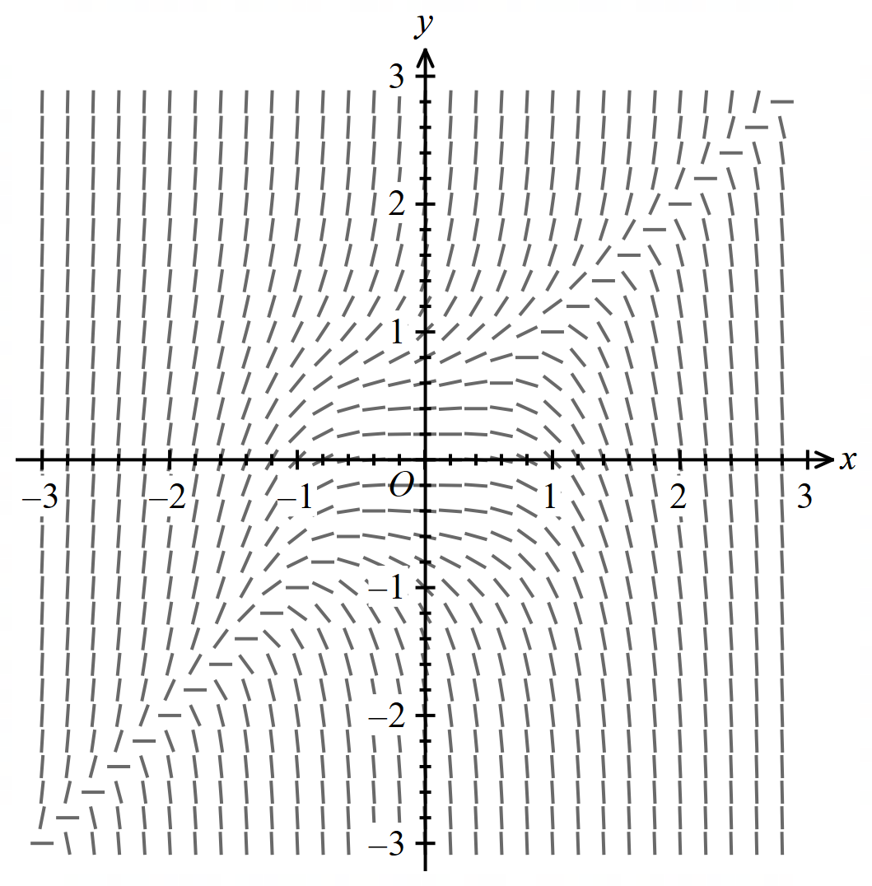

The differential equation that has the diagram above as its directional field is

A.
B.
C.
D.

Question 19

A factory contains four identical machines used in the manufacturing of sporting equipment. The lifetimes of each of these machines are independent and are each normally distributed with a mean of 1100 hours and a standard deviation of 200 hours. The probability that the total lifetime of the four machines is more than 5000 hours is closest to

A. 0.0668
B. 0.2266
C. 0.4256
D. 0.7734

Question 20

Scientists use a confidence interval to estimate the mean height of a population of emus.
They take a random sample of emus and calculate the mean height for the sample. This is then used to calculate the confidence interval.

If the scientists are interested in decreasing the width of this confidence interval by 80%, then the sample size should be multiplied by a factor of

A. 5
B. 20
C. 25
D. 80

SECTION B

Question 1 (9 marks)

Consider the function .

a. Determine the maximal domain D and the range of f. 1 mark

b. The region enclosed by and the y-axis over the interval is rotated
about the y-axis to form a solid of revolution. If x and y are measured in
centimetres, state the volume of this solid formed, in cm³, correct to three decimal
places. 3 marks

The solid formed is initially empty and is filled with water to a depth of h centimetres.

c. Find, in cm³, the volume of water at this depth in terms of h. 1 mark

d. The solid is being filled with the water at a rate of 45 cubic centimetres per
minute. Find the rate of change of the depth with respect to time when the depth
is 15 centimetres, correct to four decimal places. 2 marks

Now consider the function over its maximal domain , where .

e. i. Find the value(s) of a, b and c, such that for all . 1 mark

ii. Find the required conditions involving a, b and c for which the x-intercept
of the graph of is negative. 1 mark

Question 2 (12 marks)

Let , .

a. Given that . State the value of . 1 mark

b. i. Verify that is a solution to the equation . 1 mark

ii. Hence or otherwise, solve the equation , expressing
your solutions in polar form. 2 marks

The solutions to the equation lie on the circle J with equation .

c. On the Argand diagram below, sketch the circle J, as well as the solutions
to . Label the solutions with their coordinates.
2 marks
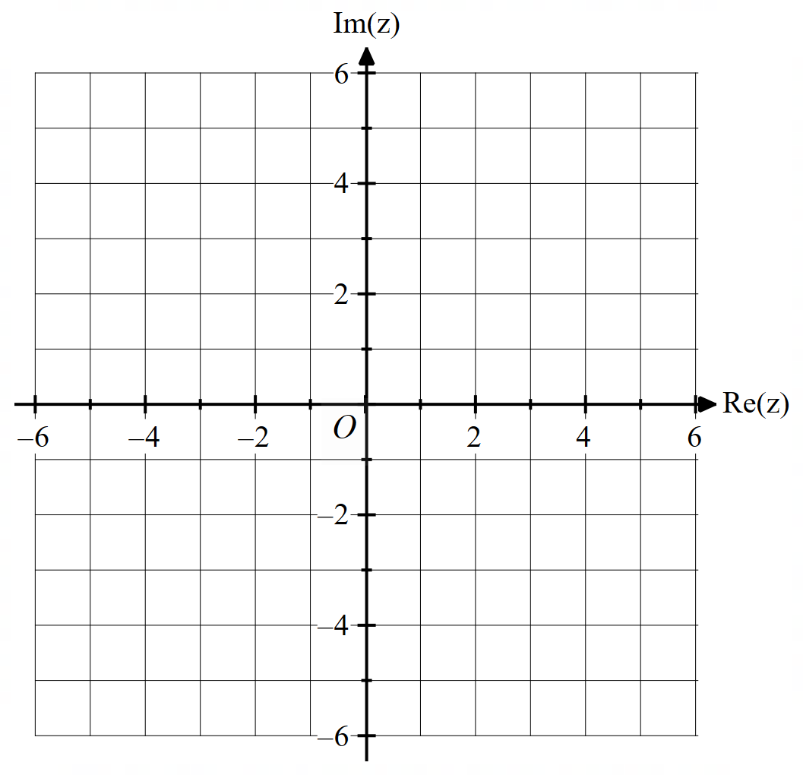

d. On the same set of axes, sketch . 1 mark

e. Find the area of the region defined by

.
2 marks

f. If and , find the minimum value of . 3 marks

Question 3 (10 marks)

A plane, , has Cartesian equation .

a. Verify that the points, and lie on . 1 mark

b. Hence, find a vector equation of in the form
, where . 2 marks

The point P has coordinates .

c. Find the distance of P from . 3 marks

d. The point P lies on the plane . If is parallel to , state the Cartesian
equation of . 2 marks

e. The line L passes through the point and the point P. Determine
the point of intersection of L and . 2 marks

Question 4 (10 marks)

A packet of sausages is taken out of a freezer to defrost. It is left in a room which has a constant temperature of .

The temperature of the packet of sausages t minutes after it is removed from the freezer is given by the differential equation

where is a constant.

a. Show that , where A is a constant. 3 marks

The packet of sausages came out of the freezer with a temperature of .

b. Show that . 1 mark

After 30 minutes, the temperature of the packet of sausages is .

c. Find the rule for the temperature, T, of the packet of sausages at any time t.
Give your answer in the form , where c, d and f
are positive integers. 3 marks

d. On the set of axes below, sketch the graph of T against t for .
Label the T-intercept with its coordinates and the asymptote with
its equation. 2 marks

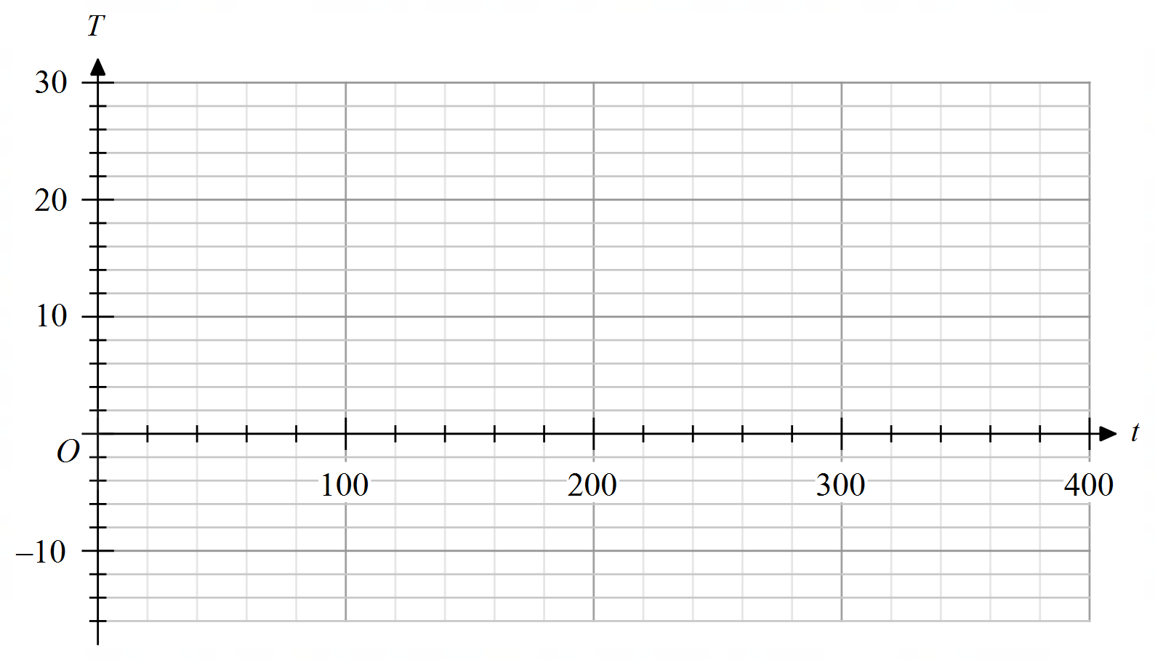

e. The sausages are best cooked when they reach . How long after being
removed from the freezer should the sausages be left to sit in the room before being
cooked? Give your answer in minutes correct to one decimal place. 1 mark

Question 5 (9 marks)

At a child’s birthday party, a set of three foil helium
balloons are tied to a weight as shown.

Balloon 1 suddenly pops, and a tiny piece of foil from
it travels through the air.

The path of this piece of foil from balloon 1, relative to
the origin O where the weight rests on the ground, t
seconds after the pop, can be modelled by the vector
equation

for

where is a unit vector in an easterly direction, is a unit vector in a northerly direction and is a unit vector vertically up. Displacement components are measured in metres.

a. i. State the initial coordinates of balloon 1 and hence the initial height
of the balloon. 1 mark

ii. Find the speed of the piece of foil from balloon 1, in m/s, at time t. 2 marks

Balloon 2 is untied and begins floating up slowly into the air. This balloon has a small red dot on it and the path of this dot can be modelled by the position vector

where t is the time in seconds after it is untied and the position is again relative to the origin O on the ground where the weight rests.

b. How far does balloon 2 travel in its first four seconds after being untied?

Use the formula for an arc length in three
dimensions and give your answer in metres correct to two decimal places. 1 mark

A child at the birthday party has a small toy bow and arrow. Three seconds after balloon 2 is untied, the child fires their arrow. The tip of the arrow follows a path given by the position vector

,

where t is the time in seconds after the arrow is fired and the position is again relative to the origin on the ground.

c. Determine the value of c, so that the tip of the arrow hits the red dot on balloon 2. 2 marks

Balloon 3 is spherical in shape with an initial radius of 20 centimetres. It slowly deflates over time, such that its surface area is decreasing at a rate of 35 cm²/hour.

d. At what rate is the radius of the balloon decreasing with respect to time when the
radius is 12 centimetres? Give your answer in units of cm/hour. 2 marks

e. How long does it take, in hours, for the balloon to totally deflate
(that is, to have a radius of zero)? 1 mark

Question 6 (10 marks)

The number of visitors to a city zoo each day is normally distributed with a mean of 2500 and a standard deviation of 100.

a. Determine, correct to four decimal places

i. the probability that on any random day, the zoo has more than
2650 visitors. 1 mark

ii. the probability that the average attendance to the zoo over a five day
period is greater than 2650. 1 mark

The zoo implements an online ticketing system, and tests whether this changes the average number of visitors each day.

b. State the null and alternative hypotheses for this test. 1 mark

To test their hypothesis, management take a sample of four random days and find the average attendance to be 2600.

c. Determine the p-value for this test and hence, state whether management should
reject the null hypothesis. Test at the 5% level of significance. 2 marks

d. Another sample of size n is collected. The sample mean is found to be 2550.
What is the minimum value of n for which would be rejected? 2 marks

e. If the zoo is testing at the 5% significance level, define a Type I error and
state the probability of this error occurring. 1 mark

f. Suppose that the true average attendance is 2600. If the zoo is
using a sample of five days and testing at the 5% significance level, find the
probability that a Type II error is made. Give your answer correct to
five decimal places. 2 marks

SPECIALIST MATHS UNITS 3&4

TRIAL EXAMINATION 2

MULTIPLE-CHOICE ANSWER SHEET

STUDENT NAME ………………………….

INSTRUCTIONS

Specialist Mathematics formula sheet

Mensuration Data analysis, probability and statistics

area of a  circle segment |  | volume  of a sphere
volume of  a cylinder |  | area of  a triangle
volume of a cone |  | sine rule
volume  of a pyramid |  | cosine rule
for independent random variables
for independent identically distributed variables
approximate confidence interval for
distribution of  sample mean | mean
 | variance

Algebra, number and structure (complex numbers)

de Moivre’s theorem

Calculus Calculus – continued

product rule
quotient rule
chain rule
integration by parts
Euler’s method
arc length parametric
surface area Cartesian about x-axis

surface area Cartesian about y-axis

surface area parametric
about x-axis

surface area parametric
about y-axis

Kinematics Circular functions
acceleration
constant
acceleration
formulas

Vectors in two and three dimensions

vector scalar product

vector cross product
vector equation of a line
parametric equation
of a line
vector equation
of a plane
parametric equation
of a plane
Cartesian equation
of a plane

Mathematics Formula Sheets reproduced by permission; © VCAA. The VCAA
does not endorse or make any warranties regarding this study resource. Past
VCAA VCE® exams and related content can be accessed directly at
www.vcaa.vic.edu.au

End of formula sheet

